1. **a) i)** Let [](https://www.codecogs.com/eqnedit.php?latex=D%0) be the event of the item being defective.

[](https://www.codecogs.com/eqnedit.php?latex=P(D)%20%3D%20P(D%20%7C%20A)P(A)%20%2B%20P(D%20%7C%20B)P(B)%20%2B%20P(D%20%7C%20C)P(C)%0) (by the partition rule)

[](https://www.codecogs.com/eqnedit.php?latex=%3D%200.05%20*%20%E2%85%93%20%2B%200.03%20*%20%E2%85%93%20%2B%200.01%20*%201%2F3%20%0)

[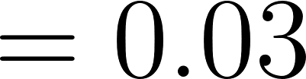](https://www.codecogs.com/eqnedit.php?latex=%3D%200.03%0)

**ii)** [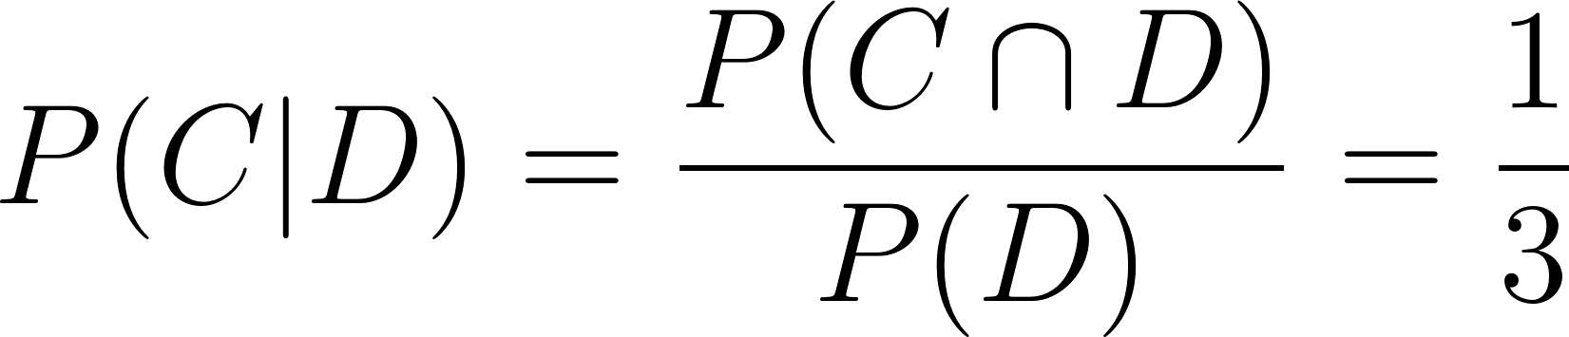](https://www.codecogs.com/eqnedit.php?latex=P(C%20%7C%20D)%20%3D%20%5Cfrac%7BP(C%20%5Ccap%20D)%7D%7BP(D)%7D%20%3D%20%5Cfrac%7B1%7D%7B3%7D%0)

**b) i)** Let [](https://www.codecogs.com/eqnedit.php?latex=R%0) be the event of a rejection, [](https://www.codecogs.com/eqnedit.php?latex=D%0) be the event of it being defective:

[](https://www.codecogs.com/eqnedit.php?latex=P(R)%20%3D%20P(R%7CD)P(D)%20%2B%20P(R%7C%5Cbar%7BD%7D)P(%5Cbar%7BD%7D)%0) again by the partition rule,

[](https://www.codecogs.com/eqnedit.php?latex=%3D%200.8%20*%200.15%20%2B%200.1%20*%200.85%0)

[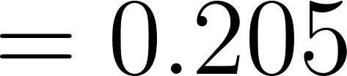](https://www.codecogs.com/eqnedit.php?latex=%3D%200.205%0)

**ii)** Fairly sure this is wrong: Let [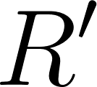](https://www.codecogs.com/eqnedit.php?latex=R'%0) be the event of a rejection under the new testing. Let [](https://www.codecogs.com/eqnedit.php?latex=R_i%0) be the event of the [](https://www.codecogs.com/eqnedit.php?latex=i%0)th test failing.

Then [](https://www.codecogs.com/eqnedit.php?latex=P(R')%20%3D%20P(R_1%20%5Ccup%20(%5Cbar%7BR_1%7D%20%5Ccap%20R_2))%20%0) i.e: the item is rejected if the first test fails OR (the first test passes AND the second test fails)

[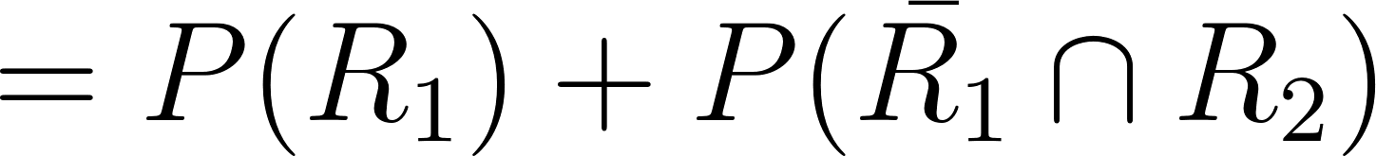](https://www.codecogs.com/eqnedit.php?latex=%20%3D%20P(R_1)%20%2B%20P(%5Cbar%7BR_1%7D%20%5Ccap%20R_2)%20%0) since the two are mutually exclusive

[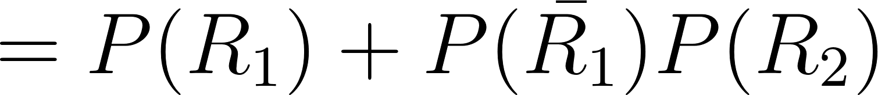](https://www.codecogs.com/eqnedit.php?latex=%20%3D%20P(R_1)%20%2B%20P(%5Cbar%7BR_1%7D)P(R_2)%20%0) since the two are independent

[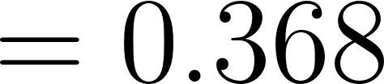](https://www.codecogs.com/eqnedit.php?latex=%20%3D%200.368%20%0)

**2)**  **a)** Exponential

**b) i)** Let [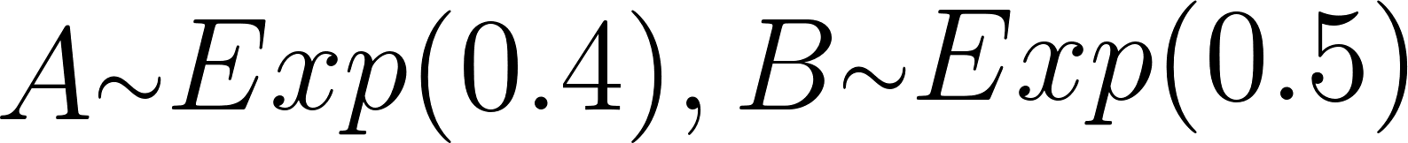](https://www.codecogs.com/eqnedit.php?latex=%20A%20%7B%5Craise.17ex%5Chbox%7B%24%5Cscriptstyle%5Csim%24%7D%7D%20Exp(0.4)%2C%20B%7B%5Craise.17ex%5Chbox%7B%24%5Cscriptstyle%5Csim%24%7D%7DExp(0.5)%20%0)

Cdf of exponential = [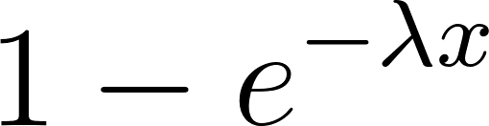](https://www.codecogs.com/eqnedit.php?latex=%201%20-%20e%5E%7B-%5Clambda%20x%7D%20%0)

[](https://www.codecogs.com/eqnedit.php?latex=%20P(A%20%3E%203)%20%3D%201%20-%20P(A%20%3C%3D%203)%20%3D%200.301%20%0)

[](https://www.codecogs.com/eqnedit.php?latex=%20P(B%20%3E%203)%20%3D%201%20-%20P(B%20%3C%3D%203)%20%3D%200.223%20%0)

**ii) 1)** [](https://www.codecogs.com/eqnedit.php?latex=%20%3D%20P(A_1%20%3E%203%20%5Ccap%20(B_1%20%3E%203%20%5Ccup%20B_1%20%3E%203%20%5Ccup%20B_1%20%3E%203))%20%0)

[](https://www.codecogs.com/eqnedit.php?latex=%20%3D%200.301%20*%20P(B_1%20%3E%203%20%5Ccup%20B_1%20%3E%203%20%5Ccup%20B_1%20%3E%203)%20%0) by independence

[](https://www.codecogs.com/eqnedit.php?latex=%20%3D%200.301%20*%20(3P(B_1%20%3E%203)%20%2B%203P(B_1%20%3E%203)%5E2%20-%20P(B_1%20%3E%203)%5E3)%0) proof left as exercise ™️

[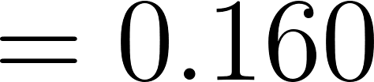](https://www.codecogs.com/eqnedit.php?latex=%20%3D%200.160%20%0)

**2)** [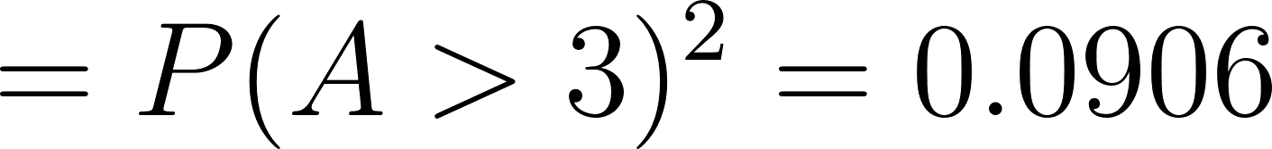](https://www.codecogs.com/eqnedit.php?latex=%20%3D%20P(A%20%3E%203)%5E2%20%3D%200.0906%20%0)

**3)** [](https://www.codecogs.com/eqnedit.php?latex=%20%3D%20P(upper%20working%20%5Ccup%20lower%20working)%20%0)

[](https://www.codecogs.com/eqnedit.php?latex=%20%3D%20P(upper%20working)%20%2B%20P(lower%20working)%20-%20P(both%20working)%20%0)

[](https://www.codecogs.com/eqnedit.php?latex=%20%3D%200.16%20%2B%200.091%20-%200.16*0.091%20%3D%200.236%0)

**3) a)** [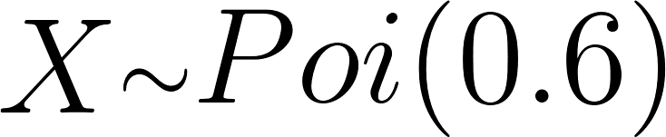](https://www.codecogs.com/eqnedit.php?latex=X%20%7B%5Craise.17ex%5Chbox%7B%24%5Cscriptstyle%5Csim%24%7D%7D%20Poi(0.6)%0)

**b) i)** 0.549 (just applying given Poisson formula)

**ii)** [](https://www.codecogs.com/eqnedit.php?latex=%20P(X%20%3E%202)%20%3D%201%20-%20P(X%20%3C%3D%202)%20%3D%201%20-%20(P(X%20%3D%200)%20%2B%20P(X%20%3D%201)%20%2B%20P(X%20%3D%202))%20%3D%20...%20%3D%200.023%20%0)

**c)** Probability of 0 errors = 0.549 from above, so [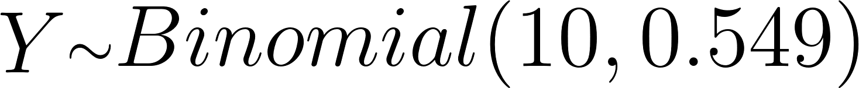](https://www.codecogs.com/eqnedit.php?latex=Y%20%7B%5Craise.17ex%5Chbox%7B%24%5Cscriptstyle%5Csim%24%7D%7D%20Binomial(10%2C%200.549)%0), then [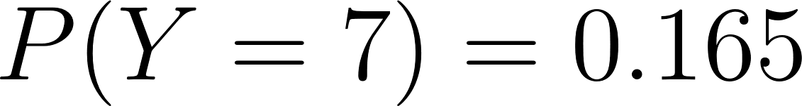](https://www.codecogs.com/eqnedit.php?latex=P(Y%20%3D%207)%20%3D%200.165%20%0) applying Binomial formula

**d)** Likelihood function = [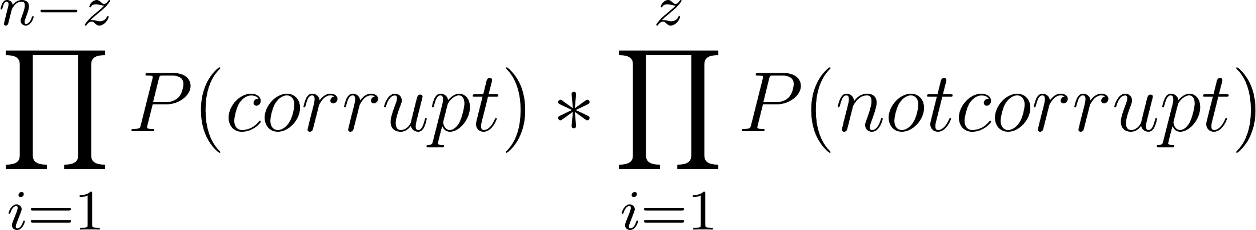](https://www.codecogs.com/eqnedit.php?latex=%5Cdisplaystyle%20%5Cprod_%7Bi%3D1%7D%5E%7Bn-z%7DP(corrupt)%20*%20%5Cdisplaystyle%20%5Cprod_%7Bi%3D1%7D%5E%7Bz%7DP(not%20corrupt)%0)

[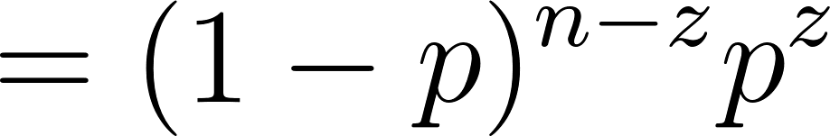](https://www.codecogs.com/eqnedit.php?latex=%20%3D%20(1%20-%20p)%5E%7Bn%20-%20z%7Dp%5Ez%20%0)

[L](https://www.codecogs.com/eqnedit.php?latex=%20%3D%20(1%20-%20p)%5E%7Bn%20-%20z%7Dp%5Ez%20%0)og likelihood function = [](https://www.codecogs.com/eqnedit.php?latex=(n-z)%5Clog(1-p)%20%2B%20z%5Clog(p)%0)

Differentiate to get [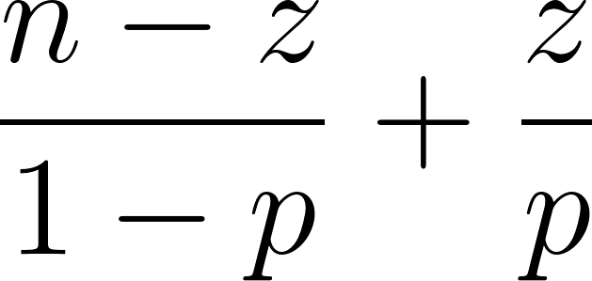](https://www.codecogs.com/eqnedit.php?latex=%5Cdfrac%7Bn-z%7D%7B1-p%7D%20%2B%20%5Cdfrac%7Bz%7D%7Bp%7D%0), set to 0 and solve to get [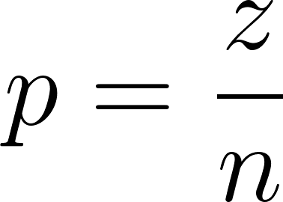](https://www.codecogs.com/eqnedit.php?latex=p%20%3D%20%5Cfrac%7Bz%7D%7Bn%7D%0)

**e)** Plug in z=8, n=10 to the above to get 0.8

**4) a)** [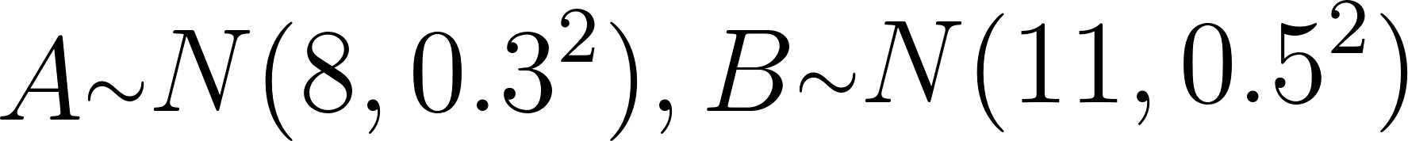](https://www.codecogs.com/eqnedit.php?latex=A%20%7B%5Craise.17ex%5Chbox%7B%24%5Cscriptstyle%5Csim%24%7D%7D%20N(8%2C%200.3%5E2)%2C%20B%20%7B%5Craise.17ex%5Chbox%7B%24%5Cscriptstyle%5Csim%24%7D%7D%20N(11%2C%200.5%5E2)%20%0)

[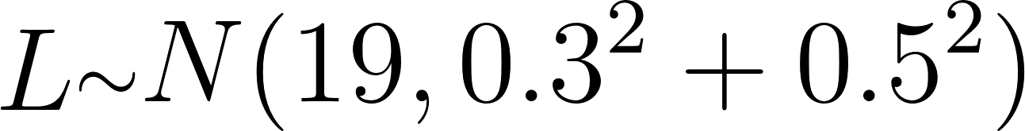](https://www.codecogs.com/eqnedit.php?latex=L%20%7B%5Craise.17ex%5Chbox%7B%24%5Cscriptstyle%5Csim%24%7D%7D%20N(19%2C%200.3%5E2%20%2B%200.5%5E2)%20%0)

**b) i)** [****](https://www.codecogs.com/eqnedit.php?latex=P(L%20%3C%2018.2)%20%3D%20%E2%80%A6%20%3D%200.081%20%0) standard Normal stuff

**ii)** 0.159, standard Normal stuff again

**iii)** 1 - (0.081 + 0.159) = 0.76

**c)** Then B must be between 10.1 and 11.5cm

[](https://www.codecogs.com/eqnedit.php?latex=P(10.1%20%3C%20B%20%3C%2011.5)%20%3D%20F_B(11.5)%20-%20F_B(10.1)%20%3D%20%E2%80%A6%20%3D%200.805%0)

**d)** This is just a normal application of a t-test, I ended up with confidence interval [18.85, 18.996] which would mean that the old mean (19) falls out by a tiny amount, so I concluded that mean did change.